2011 KOREA CUP INTERNATIONAL YACHT RACE
May 30~ June 6, 2011

Notice of Race

Organising Authority: Korea Sailing Federation (KSAF) in conjunction with Gyeongbuk Sailing Association, Pohang Sailing Association
Sponsors: Ministry of Culture, Sports and Tourism, Pohang City, Ulleung County, Korea Coast Guard, ROK Navy Headquarters, Sejung Corporation

1. | Rules
 | ISAF Racing Rules of Sailing (RRS) 2009 - 2012, ORC International/ORC Club Rules, KSF Special Handicap Rating System, OSR 2010-2011, and Sailing Instructions.
2. | Advertisements
 | This is a Category C event and all boats may be required to affix advertisement materials onto the boats.
3. | Qualifications for Participants and Entries
 | 3.1 | Classes  - IRC  - ORC  - Open
 |  | The minimum number of entries for IRC and ORC is 5 respectively. The organizing authority may cancel IRC or ORC if fewer than 5 entries have been received by the closing date. In this event, boats that have entered will have the option of transferring to another class.
 | 3.2 | Requirements  - Mono hull keelboat of 9 m and longer  - The boats for IRC and ORC must have their respective rating certificates 2011.
 | 3.3 | All Korean participants must be current members of Korea Sailing Federation.
 | 3.4 | All Korean boats must be registered with Korea Sailing Federation.
 | 3.5 | Entries
 |  | a) | The attached entry forms for this event must be submitted to KSAF by no later than March 24, 2011.
 |  | b) | Late entries may be accepted up to March 31, 2011 at the discretion of the Organizing Committee, but only upon payment of one and a half the entry fee.
 |  | c) | Boats must submit the following documents in addition to the entry form  - Safety checklist [a form of which will be posted on the race homepage]  - Respective rating certificates 2011 for IRC and ORC boats
 |  | d) | The Organizing Committee has the right to close early any class of boats for the race if the class exceeds 20 boats.
 |  | e) | All skippers that have submitted entries for the race must complete a race registration and submit it to the Race Headquarters by no later than June 1, 2011, 1500 hours.
 | 3.6 | For safety reasons, boats must have at least 4 persons on board, and their names must be included in the Race Registration.
4 | Entry Fee
 | 4.1 | At the time of submitting the entry for the race, the following entry fees must be paid:  200,000 Won per boat, plus 20,000Won per person  Bank Account for remittance of entry fee: Suhyup Bank, Seoul, Korea, Account: 643-01-006772 (Account Holder: Korea Sailing Federation)
 | 4.2 | Entry fees are non-refundable
5. | Event Schedule
Date | Time | Event | Comments
5.29 | 0900-1800 | Race Headquarters open | Pohang
5.30 | 0900-1800 | Registration/Measurements/Safety Inspection | Pohang
5.31 | 0900-1800 | Registration/Measurements/Safety Inspection | Pohang
6. 1  Wed. | 0900-1000 | Skippers’ Meeting (Yeongil Bay Inshore Race) | Pohang
6. 1  Wed. | 1100-1600 | Yeongil Bay Inshore Race | Pohang
6. 1  Wed. | 1900-2100 | Opening Ceremony and Award Ceremony for Yeongil Bay Inshore Race | Pohang
6. 2  Thur. | 0900-1000 | Skippers’ Meeting | Pohang
6. 2  Thur. | 1100 | Start of Offshore Race Leg 1  Pohang → Ulleung Island  (127 miles /26-hours time limit) | Pohang
6. 3 | 1300 | Offshore Race Leg 1 Finish | Ulleung Island
6. 4  Sat. | 0900-1000 | Skippers’ Meeting (Ulleung Island Inshore Race) | Ulleung Island
6. 4  Sat. | 1100-1500 | Ulleung Island Inshore Race | Ulleung Island
6. 4  Sat. | 1800-2000 | Welcome Party and Award Ceremony for Ulleung Island Inshore Race | Ulleung Island
6. 5  Sun. | 0000 | • Start of boat parade from Ulleung Island to Dokdo Island  (56 miles) | Ulleung Island
6. 5  Sun. | 1000 | • Start of Offshore Race Leg 2: Dokdo → Pohang  (155 miles / 29-hours time limit) | Dokdo Island
6. 6  Mon. | 1500 | • Finish of Offshore Race, Leg 2 | Pohang
6. 6  Mon. | 1900-2100 | • Award Ceremony for Offshore Race and Closing Ceremony | Pohang

6. | Measurements and Safety Inspection
 | For the purpose of safety and ratings, an official measurer will measure the boat, and also inspect the boat for safety compliance items.
7. | Sailing Instructions
 | Sailing instructions for the race will be posted on the race website and distributed at the race headquarters from May 31, 2011.
8. | Race Location
 | Appendix 1 shows the locations of the race venue.
9. | Penalties
 | 9.1 | Rule 44.1 and 44.2 shall apply
 | 9.2 | The decisions of the international jury for the race shall be final, in accordance with Rule 70.5.
10. | Scoring
 | 10.1 | For Keelboats participating in the Offshore Race ISAF Race Rules Appendix A3 shall apply.
 | 10.2 | The KSAF Ratings under the Special Handicap Rating System shall be determined by the Official Measurer and Race Committee and cannot be protested. (RRS 61 amend)
 | 10.3 | For Offshore Race Leg 1 and Leg 2, only one leg needs to be completed in order to constitute the race.
11. | Support Boats
 | Official Support Boats shall fly the flag designated by the Race Committee.
12. | Moorage
 | Participating boats and Race Committee boats shall be moored at a place designated by the Organizing Committee.
13. | Raising of boats to land restricted
 | Boats must stay in the water after the initial launch at the race venue and must not be raised onto land during or between races (unless prior written permission is obtained from the Race Committee).
14. | VHF
 | All boats must have a VHF on board during races on channels designated by the Race Committee. In the event the Race Organizers provide the participating boats with a GPS tracking instrument, they must be used all throughout the races.
15. | Awards
 | 15.1 | Details on awards will be announced later.
 | 15.2 | 10% of all award money shall be deducted for donation to help poor countries and children designated by KSAF, such as through UNICEF.
16. | Safety
 | In accordance with Rule 1.02 of OSR, the safety and control of each participating boat and its crew is the responsibility of the person in charge of the boat and its crew. This is OSR Category 3 race. The person in charge must guarantee that the boat is safe and seaworthy for the race.
17. | Responsibility and Liability
 | The decision to sail and participate in this race is made by the sailors of each boat, who are responsible for their own safety. The organizations, companies and individuals running this race, such as the Race Committee, Host, sponsors, Organizing Committee, cooperating companies, etc. shall not be held liable for any injuries, death or property damage suffered by the participating sailors or third parties before, during or after the race.
18. | Boat Travel Cost Subsidy
 | 18.1 | By taking the Race Venue (Pohang) as the reference point, a boat travel cost subsidy will be paid, depending upon the distance the boat had to travel to get to the Race Venue and the amount of subsidy will be announced later. If a boat finishes only the first leg of the Offshore Race, the subsidy will be reduced to 30% of the amount that would otherwise have been paid. If, however, the Organizing Committee determines that the boat could not finish the Offshore Race Leg 1 or Leg 2 due to unavoidable circumstances, they may decide to pay all or a part of the subsidy amount.
 | 18.2 | For specially invited foreign sailors who do not bring in their own boat but use boats provided by the Race Organizing Committee, there is no subsidy paid for boat travel costs. However, the Organizing Committee may decide to pay for all or a portion of their airfare and domestic transportation expenses, hotel expenses, and may decide to provide the use of a boat free of charge.
 | 18.3 | All boat travel subsidy payments shall have 10% deducted for charitable donations to poor countries and children designated by KSF (such as UNICEF donations).
19. | Race Insurance  Third party liability insurance, which is readily obtainable for racing in foreign countries, is difficult or impossible to obtain in Korea. Thus, the Organizing Committee will not require race participants to carry such insurance. However, the Organizing Committee may require participants to subscribe to travel insurance or other such insurance that covers one’s own injuries and death during the race. Requirements for race insurance will be posted through amendments to this Notice of Race.
20. | Organizing Committee
Korea Sailing Federation
88 Olympics Hall, No. 903
Oryun-dong, Songpa-gu
Seoul, Korea
Telephone: 82-2-420-4392
For English Service: 82-10-2356-6917 (Jungbae PARK)
Fax: 82-2-420-4391

www.kasf.org
jayman1@naver.com

Appendix 1. Racing Area
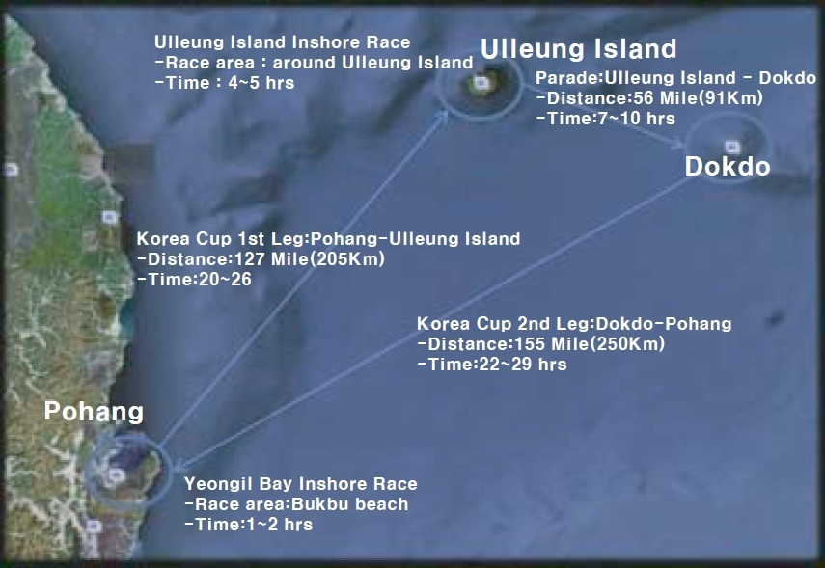

Appendix 2. Entry form
2011 Korea Cup International Yacht Race Application
Boat Identification and Specifications
Boat  Name |  |  |  |  | Manufacturer |  |  |  |  |  | Model |  | Sail  No. |  |  |  |  |  | Arrival  Date
Offshore Race ORC Int'l/Club ( )  Offshore Race Open ( )  Yeongil Bay Inshore Race Only ( ) |  |  |  |  |  |  |  |  | Home Port | LOA: |  |  | Beam: |  |  |  | LWL: |  |  | Displacement
Major sailing/racing experience:
Skipper
No. | Name | sex |  | height |  | weight | Passport No. |  |  | Birth date |  | Address |  |  |  | e-mail |  |  |  |  | Cell phone
1
Crew
2
3
4
5
6
7
8
9
10
11
12
13
14
15
Bank Account No. of person in charge of team (for remittance of prize money and boat travel subsidy)
Bank and  SWIFT CODE |  |  |  |  |  |  |  | Account  No. |  |  |  |  |  | Account Holder
I agree to comply with ISAF RRS 2009~2012, OSR-2010~2011 Rules, ORC International/ORC Club rating rules, KSAF Special Rating System, One Design Class rules, and sailing instructions.
Skipper |  |  |  |  |  |  |  |  |  | Date |  |  |  |  | Signature
2011 Korea Cup International Yacht Race Organizing Committee
Korea Sailing Federation
88 Olympics Hall, No. 903
Oryun-dong, Songpa-gu
Seoul, Korea
Tel. +82 2 420 4392, Fax. +82 2 420 4391
www.kasf.org; jayman1@naver.com

