Korea Cup Int’l Yacht Race 2016
Hupo Uljin – Dokdo – Hupo Uljin, Korea
31 August ~ 4 September, 2016
▪ Host: Korea Sailing Federation(KSAF)
▪ Organizing Authority: Korea Cup International Yacht Race Organizing Committee(OA)
▪ Sponsors: Ministry of Culture Sports and Tourism of Korea, Korea Sports Promotion Foundation,
Gyeongsangbuk-do, Uljin-gun
NOTICE of RACE (ORC Offshore Race)
1. RULE
1.1 The regatta will be governed by the rules as defined in The Racing Rules of Sailing 2013-2016.
1.2 The ISAF Offshore Special Regulations Category 2 will apply for the Korea Cup Offshore Race.
1.3 ORC Club Rules will apply for the Korea Cup Championship Race.
1.4 The National Prescription 2 will apply (If an incident results damage or injury that is obvious to the boats involved, the boat found to have breached rule by the protest committee shall be responsible and compensate for it. However, the protest committee may decide proportion of necessity.)
1.5 If there is a conflict between languages the English text will take precedence.
2. ADVERTISING
2.1 ISAF Advertising Code will apply.
2.2 A boat shall display the bow numbers with advertisement, stay flags and other advertisement provided and instructed by the Organizing Authority in accordance with this Notice of Race and the Sailing Instruction.
2.3 The Organizing Authority may require the installation, at no cost to competitors, of on board video cameras, positioning devices, and guest riders. Failure to carry and operate a positioning device or to carry a camera when required will lead to rejection of an entry, the cancellation of an entry or the disqualification of the boat from the race (refer RRS 76.1).
3. ELIGIBILITY
3.1 Eligibility of Boats for the Korea Cup Championship Offshore Race
3.1.1 Maximum 20 boats will be eligible to compete in the order of registration and the total number
of Korean boats may be restricted to 10 at the maximum.
3.1.2 General requirements
(a) A boat shall:
• be single mono hulled and self-righting.
• have an overall length (LOA) 10 metres(33 ft) or greater.
• have a crew that satisfies the requirements of NoR 3.2.
• and comply with ISAF Offshore Special Regulations for Category 2.
(b) OA may restrict participation of a boat with low performance by the Organizing Authority based
on ORC’s GPH.
(c) A Korean boat shall be registered to the KSAF yacht registration system at the following
website. http://www.koreacup.org/
(d) A Korean boat shall be certified (Administration, Inspection, Insurance etc.) by Korean
Boat related Law.
3.1.3 Eligibility of ORC boats
A boat may only be entered in the ORC class if the boat:
has a current year(2016), valid ORC certificate; and
complies with all of the current ORC Rating System Rules, save to the extent they are specifically
amended or excluded in this Notice of Race or the Sailing Instructions (refer RRS 78.1).
3.1.4 Eligibility of Safety Inspection All competing boats are complied with ISAF Offshore Special Regulations Category 2 for safety inspection. An eligible boat can compete by completing onsite safety inspection with the official inspector. Eligible boat may enter by completing the Safety Check List signed by the boat’s representative (skipper or the boat’s owner) and sending it, together with entry form. (See NoR 4.1)
3.2 Eligibility of Crews for the Korea Cup Offshore Race
a) The minimum number of crews including skipper on a boat is 6.
b) The age of the person representing a boat shall be 21 or greater.
c) At least 30% of the crews onboard shall have completed a Category 3 race or higher, or an
equivalent passage.
d) At least 30% but not fewer than two members of a crew, including the skipper, must have
attended a KSAF sanctioned Offshore Safety Training Program or an ISAF Offshore Personal Sea
Survival Course certificate within the last four years before the start of the race.
e) It is strongly recommended that at least 1 crew member on a boat shall hold a current First Aid
Certificate or equivalent qualification, or be a practicing medical practitioner.
f) All Korean crews shall be valid registered competitor to Korea Sailing Federation.
(Registration is renewed yearly basis and available at http://pinfo.sports.or.kr/servlets/player/Index) 3.3 It is strongly recommended that all participated teams wear a team uniform during the regatta.
4. ENTRY
4.1 Eligible boats may enter by completing the entry form and sending it, together with the following documents from 15th March to 30th June 2016, Korea local Time (UTC +9).
a) Completed and signed official entry form
b) ISAF OSR Category 2 – Safety Check List
c) Proof of Entry fee payment
d) Current ORC Certificate
e) Safety education confirmation
f) Photo of the boat in hi-res JPEG
g) Photocopy of insurance policy
4.2 Entries after the deadline may be accepted at the discretion of the Organizing Authority.
5. FEES
The non-refundable entry fee per boat should be paid by bank transfer. Total amount is the sum of fee per boat and fee for crews including a skipper.
Entry Fee | By 31st May | By 30th June
Boat Fee | KRW 300,000 | KRW 360,000
Crew Fee | KRW 40,000 x total number of crews | KRW 48,000 x total number of crews
[Bank Account Details]
• Bank: Suhyup Bank
• Account Name: Korea Sailing Federation
• Swift Code: NFFCKRSEXXX
• Account No: 1010-1100-8804
6. REGISTRAION
Each representative of a boat (owner or skipper) shall complete onsite registration at the Race Office
located at the Hupo Harbor as per the following schedule.
7. SCHEDULE
Aug. 30 | 1000~ | Pontoons available for berthing
Aug. 31 | 1000~1700 | Registration, Safety check
Sep. 01 | 0900~1000  1000~1600  1300~1600  1800~2000 | Skipper Meeting  Registration, Safety check  Safety Clinic  Opening Ceremony
Sep. 02 | 0800~0900  0900~1100  1055~ | Skippers Meeting  Initiation Ceremony  1st Warning Signal
Sep. 03 | 0900~1000
Sep. 04 | 1800~2000 | Prize Giving Ceremony
*CIQ Desk opens from 10:00 to 17:00 between 28th August and 31st August.
8. Safety Inspection
8.1 An eligible boat shall take safety inspection by the official inspector from 30th August to 1st
September. A boat’s inspection place and time can be decided by discussion with the OA or the
official inspector.
8.2 A boat or equipment may be inspected at any time for compliance with certificates, RRS, ORC
Certificate, Notice of Race and Sailing Instructions.
8.3 Failure to pass the safety inspection may lead to the boat’s cancellation of an entry or
disqualification of the boat from the race
9. SAILING INSTRUTIONS
Sailing Instructions will be available when registration at the venue..
10. VENUE
Attachment A shows the location of the regatta areas.
11. RACING AREA AND THE COURSES
The diagrams in Attachment B show the racing areas, courses, including the approximate distance between the legs.
12. SCORING Race results will be determined by corrected times calculated by ORC.
13. INTERNATIONAL JURY
An International Jury appointed according to the RRS Appendix N will supervise the event, and decision of the jury will be final as provided in rule 70.5.
14. BERTHING
Boats shall be kept in their assigned places while they are in the harbor.
15. HAUL-OUT RESTRICTIONS
Keelboats shall not be hauled out during the regatta except with and according to the terms of prior written permission of the race committee.
16. MEDIA RIGHTS
Competitors, owners and their guests give absolute right and permission to the Organizing Authority for any photography and video footage taken of persons and boats during the event, to be published and/or broadcast in any media, including but not limited to TV advertisements, whatsoever for either editorial or advertising purposes or to be used in press information.
17. COMMUNICATION
Boats shall maintain a 24 hour listening for the duration of their race on the VHF Channel assigned by the Organizing Authority.
18. PRIZES
18.1 The Korea Cup and prize money will be awarded to the winner of Offshore race.
18.2 Trophy and prize money will be awarded to 2nd, 3rd, 4th, 5th positions and first finished boat.
18.3 General Rule
(a) 10 % of prize money will be deducted for donation to a charitable organization OA appoints.
(b) 3.3% will be deducted for Korean.
(c) For non-Korean, tax will be deducted as per tax agreement between Korea and the recipient’s
country. 4.4% will be deducted for non-Korean in case of no tax agreement is made with Korea.
(d) All prize money will be sent by bank transfer to the recipient’s bank account within 10 days
after the event.
(e) Prize money will be sent to only the recipient stated on the entry form.
18.4 Prize Money
Position | Amount (KRW)
1ST | 10,000,000/Trophy
2ND | 8,000,000/Trophy
3RD | 7,000,000/Trophy
4TH | 5,000,000/Trophy
5TH | 3,000,000/Trophy
1st Finish | 3,000,000/Trophy
18.5 Other Prizes may be awarded at the discretion of the Organizing Authority.
19. TRAVEL SUBSIDY
19.1 A boat which completes offshore race will be given travel subsidy as per the Attachment C.
19.2 A boat which fails to complete offshore race may be given all or some of the amount as per the
Attachment C at the discretion of OA.
19.3 Due to bad weather or any condition beyond the reasonable control regardless of whether a boat has completed or not, each participating boat will be given the amount in full as per the Attachment C.
19.4 Organizing Authority may reduce the amount of travel subsidy to a boat which have caused damage, loss, negligence or any form of mishap.

20. SAFETY
Boats entering for the Korea Cup Offshore Race shall comply with OSR Category 2.
21. DISCLAMIER OF LIABILITY
Competitors participates in the regatta entirely at their own risk. See rule 4, Decision to Race. The organizing authority will not accept any liability for material damage or personal injury or death sustained in conjunction with or prior to, during, or after the regatta.
22. INSURANCE
Each participating boat to the Korea Cup Offshore Race shall be insured with valid third-party liability insurance or valid Water Leisure Comprehensive Insurance for Korean participating boat.
23. FURTHER INFORMATION
For further information, please contact:
Korea Cup Int’l Yacht Race Organizing Committee c/o Korea Sailing Federation
#501 Olympic Center, 424 Olympic-ro, Songpa-gu, Seoul 05540, Korea
E-mail: 2016koreacup@naver.com
Tel. +82-2-420-4390 Fax. +82-2-420-4391

ATTACHMENT A – VENUE
Hupo Harbor, Hupo-ri, Hupo-myeon, Uljin-gun, Gyeongsangbuk-do, Korea
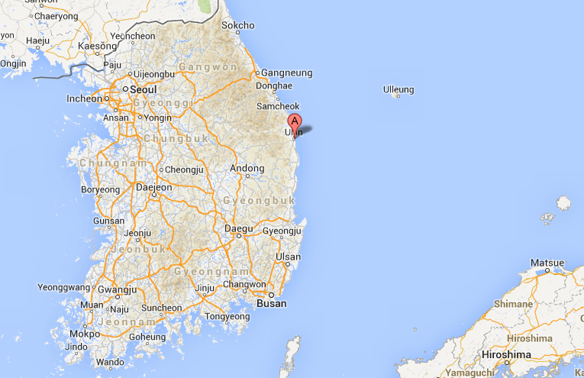
Location in Korea
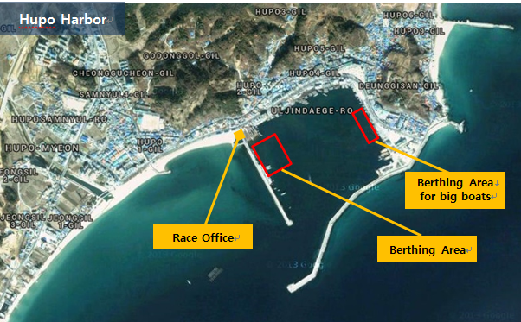
ATTACHMENT A – VENUE
Coordinate of major points
Hupo Harbor in Uljin  Venue for registration, opening ceremony  ▪Address:  Hupo-ri, Hupo-myeon, Uljin-gun,  Gyeongsangbuk-do, Korea  ▪Coordinate:  36˚40'17"N, 129˚27'19'E  (East seawall lighthouse) | 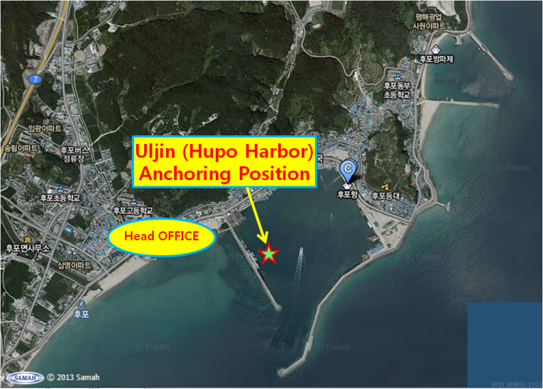
Dokdo  Destination for the friendship parade  Starting area for the offshore leg 2  ▪Address:  Dokdoisabu-gil, Ulleung-eup, Ulleung-gun, Gyeongsangbuk-do, Korea  ▪Coordinate:  37°14′20″N, 131°52′02″E  (East Islanddock) | 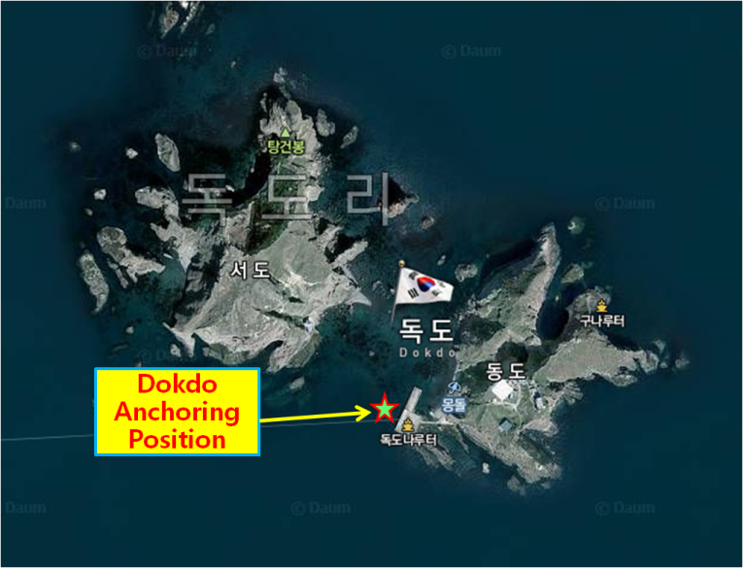

ATTACHMENT B – RACING AREA AND THE COURSES
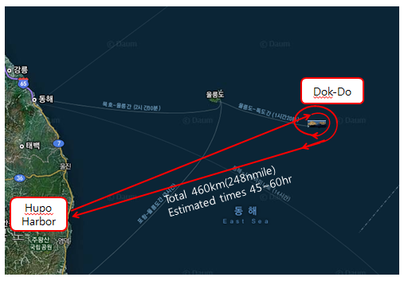
ATTACHMENT C – TRAVEL COST SUPPORT
Category |  | Distance  from the major cities | Amount (KRW)
 |  | Distance  from the major cities | Up to LOA  12 meters | More than LOA 12 meters
Korea Disabled Sailing Federation |  | Valid when more than 50% of crews are disabled. | 5,000,000
Abroad | 1,000Km and above | Qingdao China 1,057Km | 4,000,000 | 4,500,000
Abroad | Under 1,000Km | Vladivostok Russia 800Km | 3,000,000 | 3,500,000
Domestic | 800Km and above | Ttukseom Seoul 950Km | 3,000,000 | 3,500,000
Domestic | 800Km and above | Ullwangri Incheon 880Km | 3,000,000 | 3,500,000
Domestic | 600Km and above | Boryeong738Km | 2,500,000 | 3,000,000
Domestic | 600Km and above | Kyeokpo 682Km | 2,500,000 | 3,000,000
Domestic | 400Km and above | Mokpo 560Km  Seokwipo515Km | 2,000,000 | 2,500,000
Domestic | 400Km and above | Wando 440Km  Jejuhang498Km | 2,000,000 | 2,500,000
Domestic | 300Km and above | Yeosu343Km | 1,700,000 | 2,000,000
Domestic | 200Km and above | Tongyeong290Km | 1,500,000 | 1,700,000
Domestic | 100Km and above | Haeundae185Km  Susanhang177Km  Daepohang190Km | 1,000,000 | 1,300,000
Domestic | 50Km and above | Yangpo95Km  Samcheok 92Km | 500,000 | 500,000
Domestic | Under 50 Km | Ganggu 36Km | 300,000 | 300,000
- Distance is from the Departing Harbor to HupoHarbor in Ulljin.
- The distance is calculated by Organizing Authority.
- “Long distance water leisure Activity Report” will be used when calculation and OA may decide distance at their own discretion in special case.

[ENTRY FORM]

Please complete this form with the necessary documents per NoR and send to:
Korea Cup International Yacht Race Organizing Committee at 2016koreacup@naver.com

1. CLASS: □ ORC OFFSHORE RACE □ OPEN INSHORE RACE
2. BOAT
Boat name : |  |  |  | Maker / Model :
LOA: |  |  | Beam: |  | Draft :
Engine Maker& Model: |  |  |  | Engine Power (in hp):
Home Port: |  |  |  | Owner:

3. Skipper
Name: |  |  |  |  | Address:
Nationality: Sex: |  |  |  |  | Telephone:
Passport No: |  |  |  |  | Mobile:
Height (cm): Weight (Kg): |  |  |  |  | Email:
4. Crews
No. | Name | Nationality. |  | Passport # |  | e-mail |  | Others
1 |  |  |  |  |  |  |  | Height(cm):  Weigh(kg): Sex:
2 |  |  |  |  |  |  |  | Height(cm):  Weigh(kg): Sex:
3 |  |  |  |  |  |  |  | Height(cm):  Weigh(kg): Sex:
4 |  |  |  |  |  |  |  | Height(cm):  Weigh(kg): Sex:
5 |  |  |  |  |  |  |  | Height(cm):  Weigh(kg): Sex:
6 |  |  |  |  |  |  |  | Height(cm):  Weigh(kg): Sex:
7 |  |  |  |  |  |  |  | Height(cm):  Weigh(kg): Sex:
8 |  |  |  |  |  |  |  | Height(cm):  Weigh(kg): Sex:
9 |  |  |  |  |  |  |  | Height(cm):  Weigh(kg): Sex:
10 |  |  |  |  |  |  |  | Height(cm):  Weigh(kg): Sex:
5. Bank Account Details of the skipper(Remittance of prize money and travel subsidy)
Bank: |  | Account Number:
ABA No: |  | Swift Code:
Account Name:  (Beneficiary) |  | Other Information:

6. Prize money

- I am aware that the prize money will be sent to the person above by bank transfer as per NoR 18.3 and all crew members are also aware of this.

Signature:

- I agree to NoR 18.3(a) 10% of prize money will be deducted for donation to a charitable organization OA appoints.

Signature:

Agreement: I agree to be bound by the ISAF Racing Rules of Sailing (RRS), the ISAF Offshore Special Regulations, ORC Racing rules and the Notice of Race and Sailing Instructions for the race(s) concerned.
Skipper’s name: |  |  | Signature: |  |  |  | Date:

