The 6th KOREA CUP INTERNATIONAL YACHT RACE 2013

(16th ~ 22th May, 2013)

Notice of Race

Organizing Authority : Korea Sailing Federation (KSAF)
Host : Korea Cup Organizing committee(Organizing Committee), Gyeongsangbuk-do Province Office(Uljin/Ulleung)
Sponsors : Korean Olympic Committee, National Olympic Sports Promotion Foundation
Support : ROK Navy Headquarter, Korean Coast Guard, National Oceanographic Research Institute,
Sejung Corporation
 | 1. | Rules  - ISAF Racing Rules of Sailing (RRS) 2013-2016, ISAF Offshore Racing Congress (ORC) International/Club Rules, KSAF Performance Handicap Rating Fleet (PHRF), ISAF Offshore Special Regulations (OSR) 2012-2013, Notice of Race (NOR) and Sailing Instructions (SI).  - When there is a conflict between the NOR and SI, SI shall prevail (RRS 63.7).  Boats competing in Offshore RACE must follow OSR category 3.
 | 2. | Advertisements
2.1 This is a Category C event and all boats may be required to display bow numbers and advertising chosen and supplied by the OA.
2. 2 Entered boats (Other than ALT One-Design) may be required to have a camera, cameraman and support staff onboard for broadcasting purposes.
 | 3. | Eligibility and Entry
3.1 Classes
a) Korea Cup <Offshore Leg 1-2 & Ulleung Inshore>:
- ORC Class (Offshore Racing Congress)
- Open Class (PHRF: Performance Handicap Racing Fleet)
b) Korea Uljin Cup <One-Design ALT7000>:
- Fleet Race
3.2 Requirements
a) Korea Cup <Offshore Leg 1-2 & Ulleung Inshore>:
- Mono hull keelboat of 29ft(9m) or longer(ORC/OPEN), and Entries for ORC shall submit a respective rating certificates valid for 2013.

b) Korea Uljin Cup <One-Design ALT7000>:
- Fleet Race: Each team shall have 3~4 members (weight is not limited), open gender (Korean Teams shall be qualified by KSAF Race Committee).

3.3 All Korean participants must be current members of KSAF.
And Korean participants shall be registered at KSAF Homepage(https://pinfo.sports.or.kr:7005/)

3.4 Entry
a) Korea Cup <Offshore Leg 1-2 & Ulleung Inshore> :
- Maximum 30 teams, in the order of registration (OPEN Class: maximum 20 teams, other than ORC Class).
b) Korea Uljin Cup <One-Design ALT7000>:
- Fleet Race: Maximum 20 teams in the order of registration (Korean Teams shall be qualified by KSAF Race Committee).
C) ORC Rating certificate must be personally obtained and submitted along with the entry form ORC (www.orc.org) to KASF (ksaf@daum.net). For further information, contact Philip Kang, Event Dept, at +82-2-420-4392,
d) Fill in an application form on KSAF homepage/teams
(www.koreacup.org/teams/entries.asp), or the attached entry forms [Appendix 1] for this event must be submitted to KSAF by no later than 31st March, 2013. (ksaf@daum.net).
e) Late entries and any changes in boat or crew can be submitted from 8th April to 15th April, 2013 without extra charge, but after this period, any change will be allowed with only upon payment of one-and-a-half times the entry fee.
※ The allowance of additional entry after the above period for later entry and changes will be determined by Organizing Committee.
f) Participants must submit the following documents in addition to the entry form.
  - Safety checklist [Appendix 2] - to be drafted and announced later by Organizing Committee.
  - Respective rating certificates 2013 for ORC boats.
g) All skippers that have submitted entries for the race must complete a race registration and submit it to the Race Headquarters by no later than 16:00 hours on 16th May, 2013.

3.5 For safety reasons, all keel boats competing in Offshore races must have at least 4 persons on board including the Skipper, and their names must be included on the Race Registration.
 | 4  5. | Event Fee  4.1 At the time of submitting the entry for the race, the following entry fees must be paid:  4.2 Entry fees are non-refundable  Event Schedule
  KOREA CUP | All keel boats, Catamarans | 200,000 KRW per boat,  plus 20,000 KRW per person
  KOREA ULJIN CUP | Fleet Race | 20,000 KRW per person
  Bank Account for remittance of entry fee:
  Suhyup Bank, Seoul, Korea
  Account: 643-01-006772 (Account Holder: Korea Sailing Federation)
  SWIFT: NFFCKRSEXXX
  At time of remittance of entry fee, the boat name and skipper’s name must be
  expressed as in the following example: Santa Maria(Gil Dong Hong)
  Date | Time | KOREA CUP International Yacht Race  (Offshore Race Leg 1,2 & Ulleung Inshore Race) | KOREA ULJIN CUP Inshore Race  (One Design Fleet Race)
  13th May  (Mon) | 10:00～ | • Open the C.I.Q desk
  14th May  (Tue) | 10:00～ | • Open the office of Organization and Race Area
  15th May  (Wed) | 20:00～22:00 | • Race Committee and Staff Meeting | ■ 10:00~12:00 Registration / Weighting  ■ 13:00~14:00 Skippers Meeting  (Drawing Groups/ Orientation)  ■ 14:00~15:00 Demonstration  (Equipment Specification)  ■ 15:00~18:00 Practice Race  (One Design Fleet)
  16th May  (Thu) | 10:00～16:00 | • Information/Registration/Measurements/ Safety Inspection (Keel Boats) | ■ 09:00~09:30 Skippers Meeting  ■ 10:00~ Qualifying Race
  16th May  (Thu) | 16:00～17:00 | - Welcoming Orientation | ■ 09:00~09:30 Skippers Meeting  ■ 10:00~ Qualifying Race
  16th May  (Thu) | 20:00~ 22:00 | • Race Committee and Staff Meeting | ■ 09:00~09:30 Skippers Meeting  ■ 10:00~ Qualifying Race
  17th May  (Fri) | 11:00～12:00 | • Skippers Meeting | ■ 09:00~09:30 Skippers Meeting  ■ 10:00~ Semi-Final/Final Race  ■ 16:00~ Athletes interview
  17th May  (Fri) | 14:00～15:00 | • DAEPOONGHUN Festival  (Local Traditional Ceremony for Safety)
  17th May  (Fri) | 17:00～18:00 | • Press Conference & Broadcast briefing / Athletes interview
  17th May  (Fri) | 18:00～20:00 | • Opening Ceremony & Awards ( KOREA ULJIN CUP Inshore Race)  • Special performance with dinner
  18th May  (Sat) | 09:00～10:00 | • Skippers Meeting  (Offshore Race Leg 1, Friendship Parade)
  18th May  (Sat) | 14:00 | • Start of Offshore Race Leg 1. :  Uljin(Hupo Harbor) → Ulleung Island(Jeodong Harbor)/160km (86nmile)
  19th May  (Sun) | 06:00～  10:00  11:00~  11:30~ 12:30 | • Finish of Offshore Race Leg 1.  • Skippers Meeting  • Welcoming Ceremony  • Luncheon (Noodles/Traditional Food)
  19th May  (Sun) | 13:00  14:00～18:00 | • Departing for Ulleung Island Tour  • SUNGHA Festival  (Local Traditional Ceremony for Safety)  • Ulleung Island Tour
  20th May  (Mon) | 09:00～10:00 | • Skippers Meeting
  20th May  (Mon) | 13:00～16:00 | • Ulleung Inshore Race
  20th May  (Mon) | 18:00～19:00  19:00～21:00 | • Skippers Meeting  • Awards (Offshore Race Leg1 & Ulleung Inshore) & Welcoming Party
  20th May  (Mon) | 23:00 | •Farewell Ceremony &  Start of Friendship Parade :  Ulleung Island → Dokdo (Island)  /80km (43nmile)
  21st May  (Tue) | 08:00～9:30 | • Finish of Friendship Parade /  Dokdo (Island) Arrival Ceremony
  21st May  (Tue) | 11:00 | • Start of Offshore Race Leg 2. :  Dokdo (Island) → Uljin (Hupo Harbor)  /230km (124nmile) ; (Live coverage)
  22nd May  (Wed) | 10:00～15:00 | • Finish of Offshore Race Leg 2.
  22nd May  (Wed) | 18:00～20:00 | • Closing Ceremony (Awards; Offshore Leg 2 and Overall)  • Special performance with dinner
  ※23rd May(Thu) : Farewell Ceremony from Organizing Committee
 | 6. | Measurements and Safety Inspection
 |  | For the purpose of safety and ratings, an official measurer will measure the boat, and also inspect the boat for safety checklist items.
 | 7. | Sailing Instructions
 |  | Sailing instructions (SI) for the race will be posted on the race website(www.koreacup.org) and distributed at the race headquarters from May 16th, 2013
 | 8. | Race Location
 |  | [Appendix 3] shows the locations of the race venue.
 | 9. | Penalties
9.1 RRS 44.1 and 44.2 shall apply.
9.2 International jury must be constituted in accordance with Appendix N of RRS, and final decision shall be made in accordance with RRS 70.5.
 | 10. | Scoring
10.1 ISAF RRS Appendix A3 shall apply.
10.2 The KSAF Ratings under the Performance Handicap Rating Fleet shall be determined by the Official Measurer and Race Committee and cannot be protested. (this amends RRS 61)
10.3 a) For the Offshore Race Leg 1 and Leg 2, only one leg needs to be completed in order to constitute the race.
b) For the Ulleung Inshore Race, minimum of 1 race must be completed to constitute the race.
c) Only those who have participated in, and have completed, all of the races shall be eligible to receive the Korea Cup overall awards and Korea Cup completion awards.
10.4 a) Rules and further information concerning Korea Uljin Cup Match Race shall be provided in the Match Race SI.
b) Rules and further information concerning Korea Uljin Cup One-Design Fleet Race shall be provided in the Fleet Race SI. A minimum of 1 race must be completed to constitute the race.

 | 11. | Support Boats
 |  | Official Support Boats shall fly the flag designated by the Organizing Committee.
 | 12. | Mooring
 |  | Participating boats and Race Committee boats shall be moored at a place designated by the Organizing Committee.
 | 13. | Lifting of boats to land restricted
 |  | Keelboats must stay in the water after the initial launch at the race venue and must not be lifted onto land during or between races (unless prior written permission is obtained from the Race Committee).
 | 14. | VHF
 |  | All boats must have a VHF on board during races on channels designated by the Race Committee. In the event the Race Organizing Committee provides the participating boats with a GPS tracking instrument, it must be used all throughout the races.
 | 15. | Award
15.1 10% of all prize money shall be deducted for donation to help poor countries and war orphans, such as through UNICEF. Also, a tax of 4.4% shall be deducted from the prize money.
For the purpose of payment of prize money and for deductions of taxes and donations therefrom, the skipper of each team will serve as the representative of his team.

15.2 Prize Money
[Unit : KRW 1,000]
- KOREA CUP International Yacht Race
Division |  |  | Leg 1 race |  | Ulleung Inshore race |  | Leg 2 race |  | Total | Remarks
Korea Cup Trophy |  | Overall Winner  (Results for all three races shall be combined to determine the overall winner) |  |  |  |  |  |  |  | A scramble for the Cup
First Finish(Line Honors) |  | 1,000 |  | N/A |  | 1,000 |  | 2,000
ORC | 1ST Place | 6,000 |  | 1,000 |  | 6,000 |  | 13,000
ORC | 2ND Place | 4,500 |  | 800 |  | 4,500 |  | 9,800
ORC | 3RD Place | 3,000 |  | 700 |  | 3,000 |  | 6,700
ORC | 4TH Place | 2,000 |  | 600 |  | 2,000 |  | 4,600
ORC | 5TH Place | 1,000 |  | 500 |  | 1,000 |  | 2,500
ORC | Sub-Total | 17,500 |  | 3,600 |  | 17,500 |  | 38,600
OPEN | 1ST Place | 4,000 |  | 1,000 |  | 3,000 |  | 8,000
OPEN | 2ND Place | 2,500 |  | 800 |  | 2,000 |  | 5,300
OPEN | 3RD Place | 1,500 |  | 700 |  | 1,500 |  | 3,700
OPEN | 4TH Place | 1,000 |  | 600 |  | 1,000 |  | 2,600
OPEN | 5TH Place | 500 |  | 500 |  | 500 |  | 1,500
OPEN | Sub-Total | 9,500 |  | 3,600 |  | 8,000 |  | 21,100
Total Aggregate |  | 27,000 |  | 7,200 |  | 25,500 |  | 59,700
[Unit : KRW 1,000]
2013 Korea Uljin Cup Inshore Race
Division |  | FLEET RACE | Remarks
ONE DESIGN | 1ST Place | 2,000
ONE DESIGN | 2ND Place | 1,000
ONE DESIGN | 3RD Place | 500
ONE DESIGN | Sub-Total | 3,500
Total Aggregate |  | 3,500
※ All of the above prize money amounts are subject to change depending on the final budget.

 | 16. | Boat Travel Cost Subsidy for Korea Cup International Yacht Race  16.1 a) By taking the Race Venue (Uljin) as the reference point, a boat travel cost subsidy will be paid in accordance with the preliminary table of boat travel distances and subsidies provided in Paragraph 17 below. A finalized table of boat travel distances and subsidies will be announced later. If a boat finishes only one leg (such as Uljin-Dokdo leg, or Ulleung-Uljin leg) of the Offshore Race, the subsidy will be reduced to 30% of the amount that would otherwise have been paid. However, if the Organizing Committee determines that the boat could not finish the Offshore Race Leg 1 or Leg 2 due to unavoidable circumstances, they may decide to pay all or a part of the subsidy amount.  b) Boat travel cost subsidies for countries not listed below (China, Japan, Hong Kong, Singapore, United States of America, Canada, Australia, New Zealand, England, France etc.) may be paid up to the highest rate applied in the table below for foreign boats or will be subject to negotiations.  c) In order to provide some transportation and lodging expense subsidies for foreign competitors (who are not already in Korea) who are invited to join Korean teams in the Korea Cup International Yacht Race, the Organizing Committee may provide such team with a subsidy of 1 million won, in addition to the boat travel cost subsidy mentioned above. Only such teams that have been approved by the Organizing Committee beforehand as a “United Team” will be eligible to receive such subsidy16.2.  16.2 All boat travel subsidy payments shall be paid to the skipper of each team.  16.3 All participation teams must fill out Long Distance Water Leisure Activities card and submit it local Korea Coast Guard before departure to the race venue (Uljin), and copy of the card should be submitted at registration. The Long Distance Water Leisure Activities card may be used for calculation of boat travel cost subsidies.
 | 17. | Boat Travel Cost Subsidy Amount
  Distance  (nmile);(km) |  | Division  (nmile);(km) | Amount  (unit; KRW 10,000)
   |  | Division  (nmile);(km) | Under 40ft(12.2m) | 40ft(12.2m) and More
  Abroad | (540);(1,000) | China Qingdao (571);(1,057) | 500 | 550
  Abroad | (405);(750) | Russia Vladivostok (432);(800) | 400 | 450
  Domestic | (486~540)  ;(900~1,000) | Seoul Dduksum (513);(950) | 500 | 550
  Domestic | (432~486)  ;(800~900) | Ullwangri (475);(880) | 450 | 500
  Domestic | (378~432)  ;(700~800) | Boryeong (398);(738) | 400 | 450
  Domestic | (324~378)  ;(600~700) | Kyeokpo (368);(682) | 350 | 400
  Domestic | (270~324)  ;(500~600) | Mokpo (302);(560),  Seokwipo (278);(515) | 300 | 350
  Domestic | (216~270)  ;(400~500) | Wando (238);(440),  Jejuhang (269);(498) | 250 | 300
  Domestic | (162~216)  ;(300~400) | Yeosu (185);(343) | 200 | 250
  Domestic | (108~162)  ;(200~300) | Tongyeong (157);(290) | 150 | 200
  Domestic | (54~108)  ;(100~200) | Haeundae (100);(185), Susanhang (96);(177),  Daepohang (103);(190) | 100 | 150
  Domestic | (27~54)  ;(50~100) | Yangpo (51);(95),  Samcheok (50);(92) | 50 | 100
  Domestic | (Under 27)  ;(Under 50) | Ganggu (21);(36) | 30 | 80
  ※ From Uljin (Hupo Harbor) to the Departing Harbor.
  ※ The distance shell be calculated by Organizing Committee.
 | 18. | Safety
 |  | In accordance with Rule 1.02 of OSR, the safety and control of each participating boat and its crew is the responsibility of its crew. Boats competing in Offshore Race must follow OSR Category 3, and boats competing in the Inshore Race must follow ORS Category 5.
 | 19. | Responsibility and Liability
 |  | The decision to sail and participate in this race is made by the sailors of each boat, who are responsible for their own safety. The organizations, companies and individuals running this race, such as the Race Committee, Host, sponsors, Organizing Committee, cooperating companies, etc. shall not be held liable for any injuries, death or property damage suffered by the participating sailors or third parties before, during or after the race.
 | 20. | Race Insurance
Ordinarily, all participating boats must carry third party liability insurance.
However, third party liability insurance, which is readily obtainable by boat owners for racing in foreign countries, is difficult or impossible to obtain in Korea. Thus, the Organizing Committee will not require race participants to carry such insurance. In place of such insurance, the Organizing Committee may require participants to subscribe to travel insurance or water leisure activity insurance that covers one’s own injuries and death during the event. All domestic competitors who have not already subscribed to such insurance must, after first registering as an athlete with the Korean Olympic Committee (including registration as an organized group)submit proof of the insurance that KSAF has designated (the homepage of KSAF-designated insurance company is DONGBOO INSURANCE CO., LTD ; http://dongbu.ufinsu.com).
 | 21. | Organizing Committee
2013 Korea Cup International Yacht Race Organizing Committee
88 Olympics Hall, No. 903, Oryun-dong, Songpa-gu, Seoul, Korea
Telephone: 82-2-420-4392 (Philip Kang)
Fax: 82-2-420-4391
Website : www.koreacup.org , Email : ksaf@daum.net

Appendix : 1. Entry Form
2. Safety Checklist
3. Racing Area

Appendix 1. Entry form
2013 Korea Cup International Yacht Race Entry Form
1 ⃞ RACE <Mark V ⃞ at the Participating Class>
KOREA CUP INTERNATIONAL YACHT RACE |  |  |  |  |  |  |  |  |  |  |  |  |  | KOREA ULJIN CUP INSHORE RACE
ORC □ |  |  |  |  | OPEN □ |  |  | CATAMARAN □ |  |  |  |  |  | Fleet Race □  (All Competitors)
2 ⃞ Boat Identification and Specifications <not applicable for KOREA ULJIN CUP>
Boat Name |  |  |  |  |  |  |  |  | Manufacturer |  |  |  |  |  |  | Model
LOA(m)  (Length overall) |  |  |  |  |  |  |  |  | BOA(m)  (Beam overall) |  |  |  |  |  |  | Draft(m)
Engine Name & power (hp) |  |  |  | / hp |  |  |  |  | Home Port |  |  |  |  |  |  | Arriv. Date
3 ⃞ Skipper
Photo |  |  |  |  |  |  |  |  | Major sailing/racing experience
No. | Name |  | Sex | Tall  (cm) |  | Weight  (kg) | Country. |  | Passport No. |  | Address |  |  |  |  |  | e-mail |  |  |  | Mobile - phone
1
4 ⃞ Crew <If more than 8 members, attach another sheet>
2
3
4
5
6
7
8
5 ⃞ Bank Account No. of team skipper (for remittance of prize money and boat travel subsidy)
Bank and  SWIFT CODE |  |  |  |  |  |  |  |  |  | Account  No. |  |  |  |  |  |  |  | Account Holder
I agree to comply with ISAF RRS 2013~2016, OSR-2012~2013 Rules, ORC International/ORC Club rating rules,
KSAF Special Rating System, Notice of Race and Sailing Instructions.
Skipper: |  |  |  |  |  |  |  | Signature: |  |  |  |  |  |  | Date:
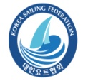 |  | 2013 Korea Cup International Yacht Race Organizing Committee  Korea Sailing Federation (KSAF)  88 Olympics Hall, No. 903 Oryun-dong, Songpa-gu, Seoul, Korea |  |  |  |  |  |  |  |  |  |  |  |  | Tel. +82 2 420 4392/Fax. +82 2 420 4391  E-mail: ksaf@daum.net  Website: www.koreacup.org
Appendix 2. Safety Check List

2013 Korea Cup international yacht race
Offshore Special Regulation Category 3. Check List

- This list is to check the ship owners themselves and some parts of yacht equipment, and it does not cover all of the OSR.
- The race committee checks only if there are the equipments required, it does not guarantee the safety of the yachts.
- Yacht owners are required to check the box of each clause and keep the original one in their boats. A copy is to be presented to the race committee at registration by 31st Mar 2013.
(fax: 02-420-4391, kasf@daum.net)

1 | The safety of a yacht and her crew is the sole and inescapable responsibility of the person in charge who must do his best to ensure that the yacht is fully found, thoroughly seaworthy and manned by an experienced crew who have undergone appropriate training and are physically fit to face bad weather. He must be satisfied as to the soundness of hull, spars, rigging, sails and all gear. He must ensure that all safety equipment is properly maintained and stowed and that the crew knows where it is kept and how it is to be used. | □
2 | Navigation lights shall not be mounted below deck level and should be at no less height than immediately under the upper lifeline. | □
3 | Navigation lights, stem lights, stern lights shall be checked. | □
4 | A passive Radar Reflector (that is, a Radar Reflector without any power) shall be provided | □
5 | Attached to through-bolted or welded deck plates or other suitable and strong anchorage fitted on deck, port and starboard of the yacht's centre line to provide secure attachments for safety harness | □
6 | a) Completely fixed, a clipping crew should be stand easy to work at lifeline on the deck.  b) The lifeline is stainless steel wire (LOA 8.5m~13m ,silver 4mm over than) not be provided plastic clothing and the yacht which uses sheet or sleeve shall be inspected regularly. | □
7 | During a race, can be charged of the battery, fuel of more than 20L available 8 hours by minimum speed and water of more than 20L for emergency survival shall be provided. | □
8 | A marine magnetic compass, independent of any power supply, permanently installed and correctly adjusted with deviation card. | □
9 | An anchor that’s ready for immediate use with 2 or more adequate rope and chain | □
10 | Foghorn | □
11 | Two or more adequately placed fire extinguishers that’s ready for immediate use. | □
12 | Tools and Spare Parts  Tools and spare parts, including effective means to quickly disconnect or sever the standing rigging from the hull (wire cutter)
13 | Yacht's name  Yacht's name shall be on all miscellaneous buoyant equipment | □
14 | Battery Systems  When an electric starter is the only method for starting the engine, the yacht shall have a separate battery, the primary purpose of which is to start the engine | □
15 | A First Aid Kit | □
16 | Marine radio transceiver VHF: that has a rated output power of 25W | □
17 | Fixing or handheld GSP | □
18 | A sailing sea chart (not electronic), lighthouse list and working tools. | □
19 | A lifebuoy with a self-igniting light and a drogue or a Lifesling with a self-igniting light and without a drogue. | □
20 | 2 red parachute and 2 red hand flares and cyalume-type chemical light sticks (red flares compliant with SOLAS) | □
21 | 2 Orange smokescreen | □
22 | A waterproof flashlight with spare batteries and bulb | □
23 | Each crew member shall have a lifejacket as follows:-  In accordance with ISO 12402 – 3 (Level 150) or equivalent, ISO 12402 requires Level 150 lifejackets to be fitted with a mandatory whistle and retro-reflective material. Also, when fitted with a safety harness, ISO 12402 requires that this shall be the full safety harness in accordance with ISO 12401. Any equivalent lifejacket shall have equal requirements. | □
24 | Snap hook on each end no longer than 2m and safety line and harness for each member on board | □
25 | Emergency steering | □
26 | Each sized coak should be provided the holes through the yacht (bilge-pump, water pump, speed gauge and toilet. etc ) | □

- The name of boat :

- Skipper’s Name: Signature:

- Date Month , 2013

Appendix 3. Racing Area
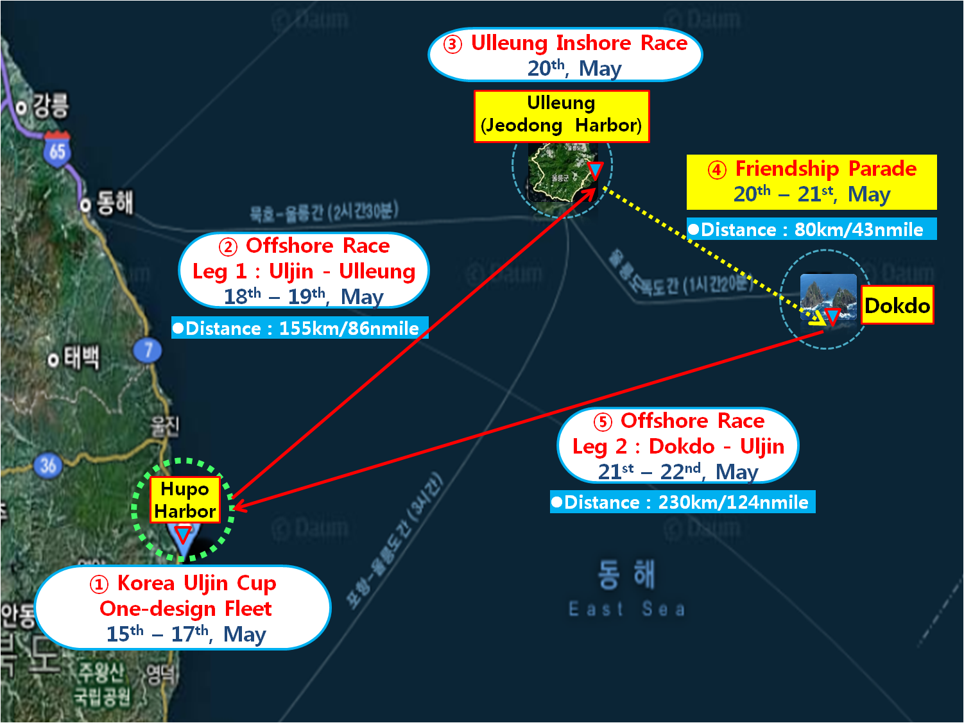

Location | Information of Race Area Weather
East Sea | - Sunrise / Sunset - 05:14 / 19:24 (Base on May 17)  - Average Temperature: Uljin 13.2°C (high 20.1°C, low 8.5°C)  Ulleung 17°C (high 21.1°C, low 14.3°C)  - Wind : Southwesterly or Southerly Wind 8~9m/s

Location | Additional information of Harbor and Mooring
1. Hupo  Harbor  (Ulljin) | - Address:  Hupo-ri, Hupo-myeon, Uljin-gun, Gyeongsangbuk-do, Korea  - Longitude & latitude  :36˚40'17"N,  129˚27'19'E  (Reference Point:  East seawall lighthouse) | 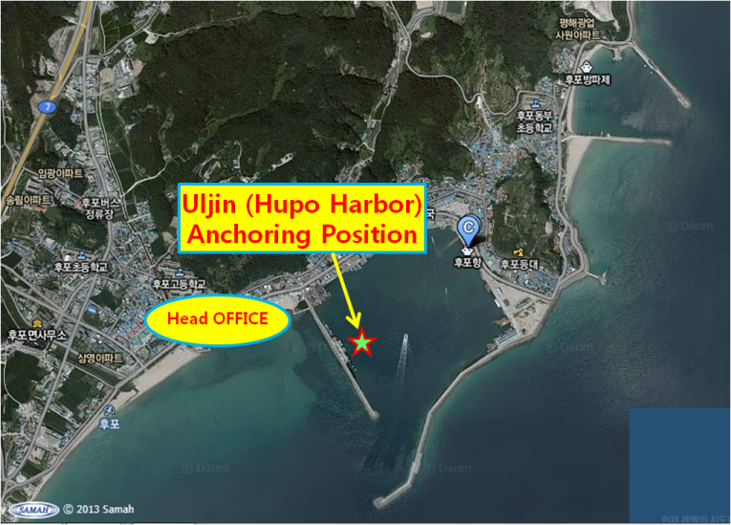
2.  Jeodong  (Ulleung  Island) | - Address:  Dodong-ri, Ulleung-eup, Ulleung-gun, Gyeongsangbuk-do, Korea  - Longitude & latitude  :37˚29'48"N,  130˚54'48"E  (Reference Point:  South seawall lighthouse) | 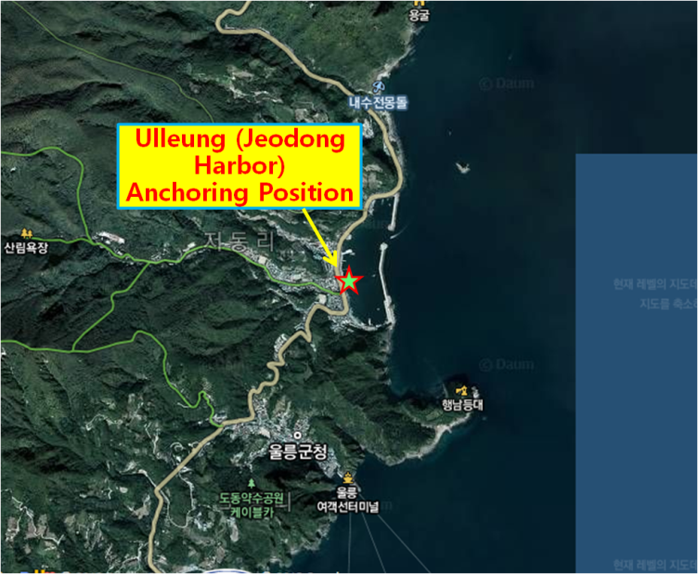
3. Dokdo  (Island) | - Address:  Dokdoisabu-gil, Ulleung-eup, Ulleung-gun, Gyeongsangbuk-do, Korea  - Longitude & latitude  :37°14′20″N, 131°52′02″E  (Reference Point:  East Island dock) | 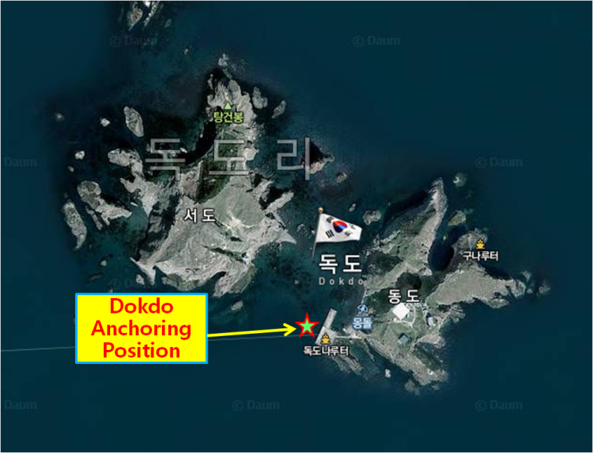
-The end-

